Alt 2 project report

**Preparation**

In the ALT 2 project which is about analytics there will be a lot of preparation. First of all we had to practice coding different types of code which we might find useful in our project for example we did code which cleaned, plotted, read and write data which might be useful in the ALT 2. We also had to look for data which we wanted to use and we found data in google datasets. We came up with a country’s gdp vs % spent on education.

**Project development and coding**

At first we started learning how to clean data using a code which we also learned how to write data into a csv file which this all went well. <https://github.com/STJRush/Group-2-ALT-2> this is a link to our github so you may look at our code for some of our past preparation such as mean,median etc. Here is the code which was used to calculate the mean and the median for our development in our project.

1-Imports statistics module

3-Creates a list of values

5-prints the list

6-calculates the mean of the list

7-calculates the median

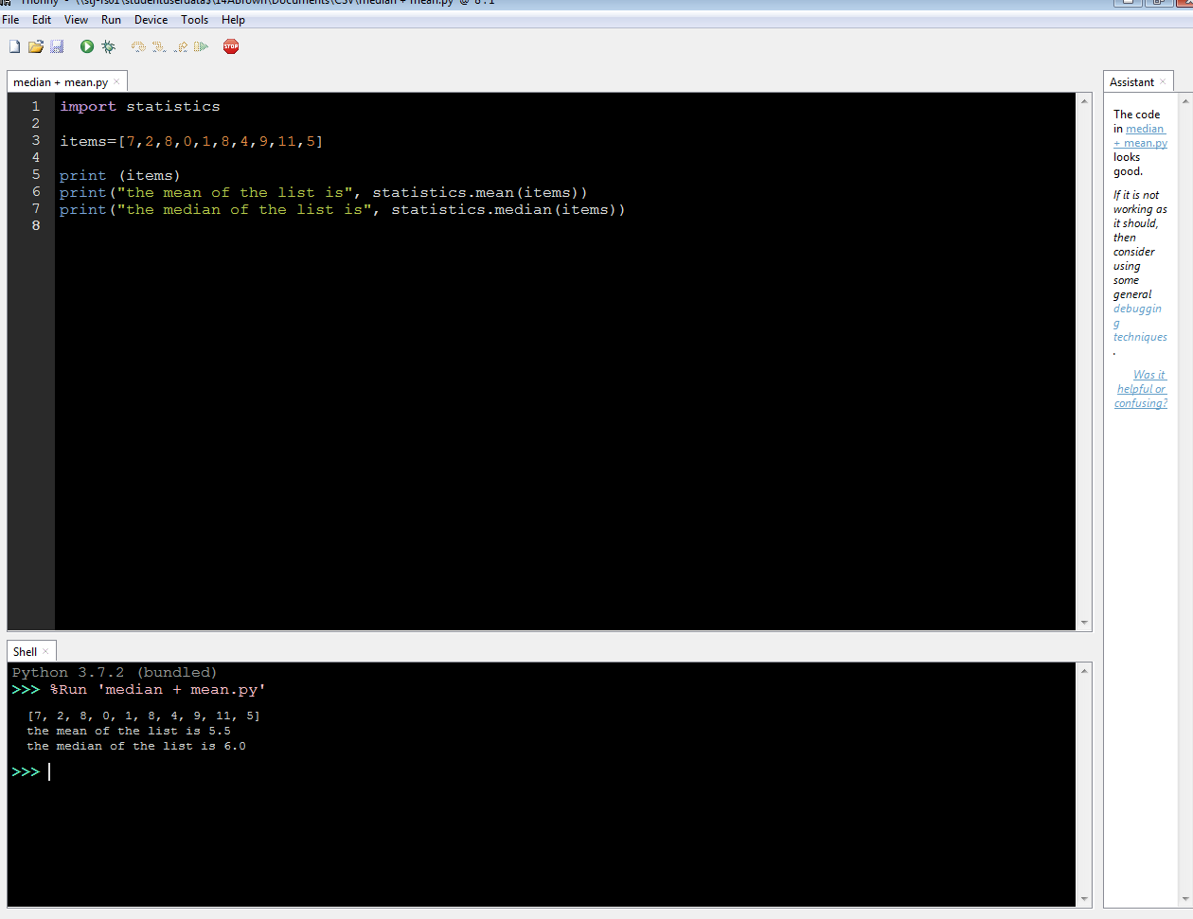

Finding the mean and median is quite easy as you can clearly see as they are the same code but one word is different.